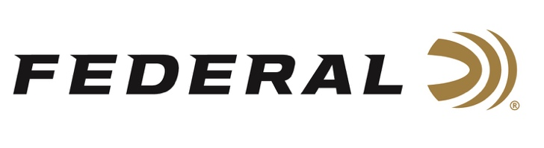

FOR IMMEDIATE RELEASE

DeTavernier Recognized for Outstanding Season

ANOKA, Minnesota – November 12, 2021 – Federal sponsored shooter Payton DeTavernier capped off a strong season with a coveted ATA certificate. The college student at Doane University in Nebraska, earned the AAA27AAA achievement recognition in trapshooting.

To qualify for this one-time designation, DeTavernier finished the year in the Lady 1 Division with an average above 98% in Singles (2,500 targets), 96% average in Doubles (750) and being on the 27 yard-line over the course of the year.

“This is an outstanding achievement,” stated Jason Nash, VP of Marketing at Federal Ammunition. “Payton was new to the Federal Team this year and we are excited to watch her growth in the shooting sports.”

According to the ATA website, DeTavernier is one of seventeen shooters who obtained this achievement during the 2021 target season. The Doane University student shoots Federal’s line-up of Premium target loads while competing.

“This achievement is something I knew I wanted to obtain since I started shooting ATA. It shows that my hard work, dedication and commitment has paid off and I couldn’t be happier,” said DeTavernier. “I have worked extremely hard to accomplish this and I wouldn’t have been able to do it without my parents, Federal, Elite Shotguns and Kolar. It means so much to me that I have an amazing support system and people who are always there to help me.”

For more information on all products from Federal or to shop online, visit www.federalpremium.com.

Press Release Contact: JJ Reich
Senior Manager – Press Relations
E-mail: VistaPressroom@VistaOutdoor.com

About Federal Ammunition
Federal, headquartered in Anoka, MN, is a brand of Vista Outdoor Inc., an outdoor sports and recreation company. From humble beginnings nestled among the lakes and woods of Minnesota, Federal Ammunition has evolved into one of the world's largest producers of sporting ammunition. Beginning in 1922, founding president, Charles L. Horn, paved the way for our success. Today, Federal carries on Horn's vision for quality products and service with the next generation of outdoorsmen and women. We maintain our position as experts in the science of ammunition production. Every day we manufacture products to enhance our customers' shooting experience while partnering with the conservation organizations that protect and support our outdoor heritage. We offer thousands of options in our Federal Premium and Federal® lines-it's what makes us the most complete ammunition company in the business and provides our customers with a choice no matter their pursuit.

###

